Clothing Drive
Girls and boys shirts and pants all youth sizes.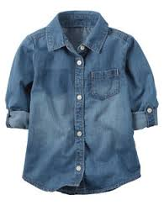 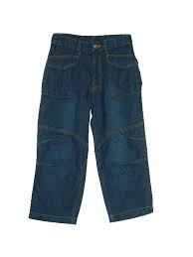 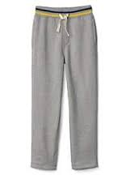 Girl Scout Troop # 60209 Meghan and Heather
Please drop gently used clothing items into the colorful boxes.
This is to help Plank North Students

This is to help kids who can't access clothing and need a little help. Thank you for your contribution to our community.

This project is to help us earn our silver award for Girl Scout troop 60209. If you have questions please refer them to our troop leaders Heather and Nancy:
Heather: 1(585)613-6537 Nancy: 1(512)699-3840

